Ikariam – Navy

## Collection of common field compositions – Open sea

Contents

Collection of common field compositions – Open sea 1

Full rocket artillery line combinations 2

Full Dives artillery lines 5

## Full rocket artillery line combinations

Full steam vs full fire frontline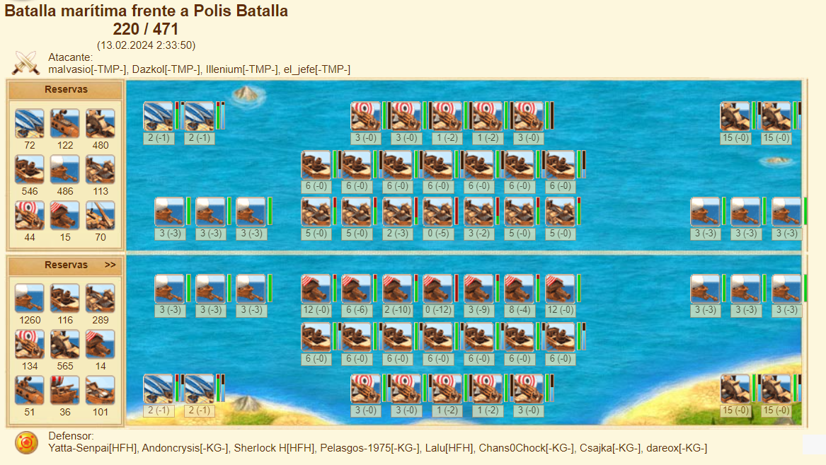

Both sides forged

Fires not forged

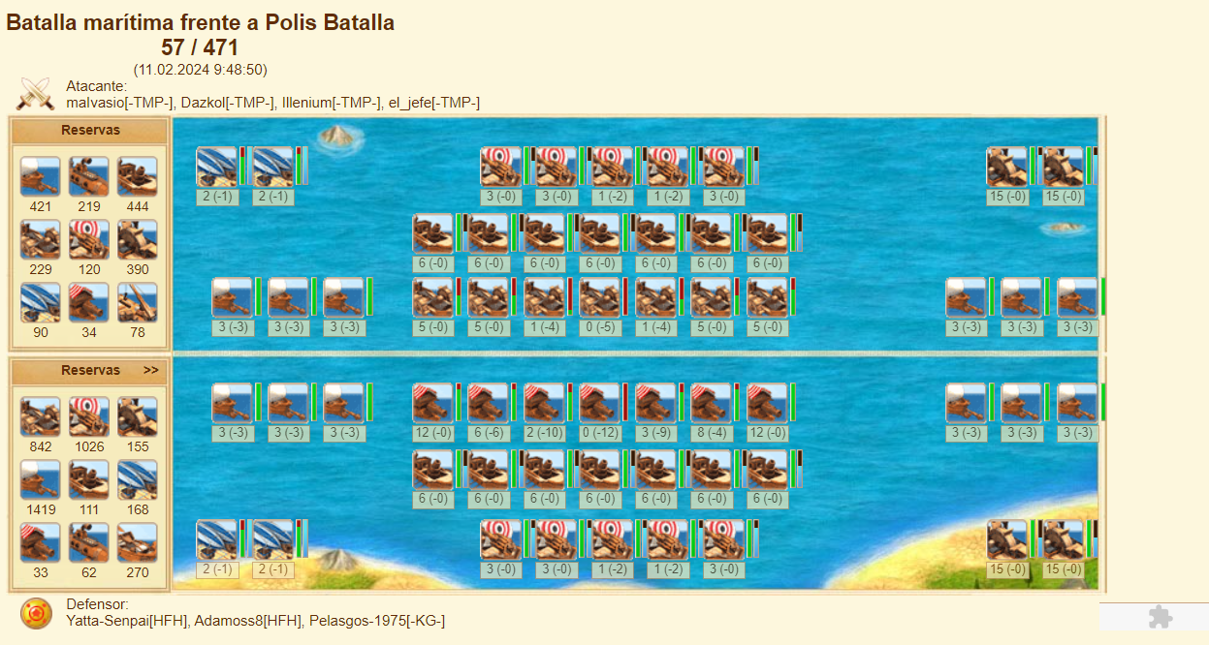

Full steam vs Full steam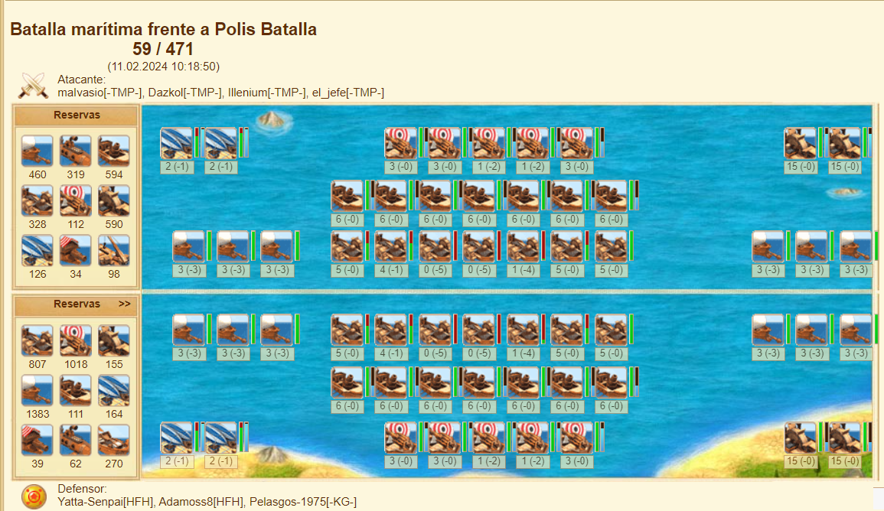

3Waved fires vs 3Waved fires

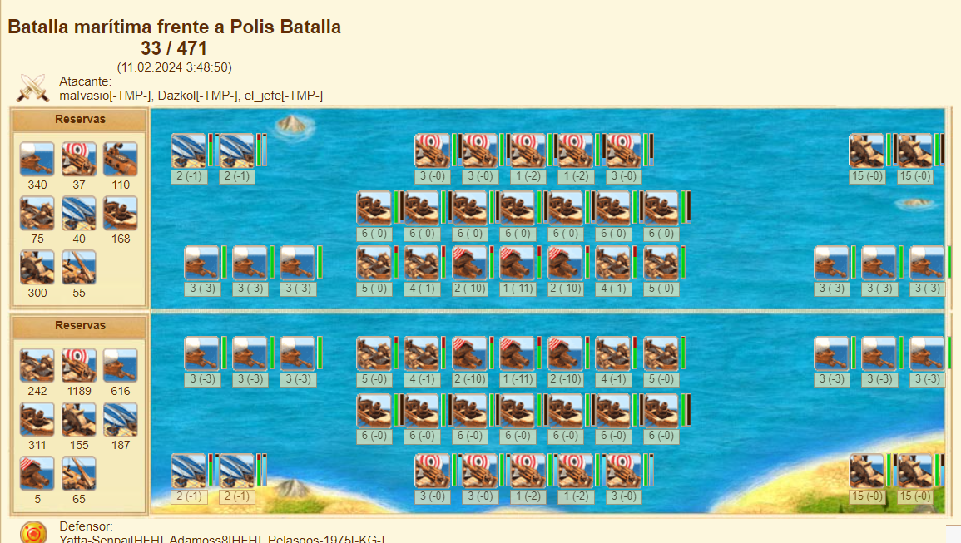

Full steam vs 3waved fires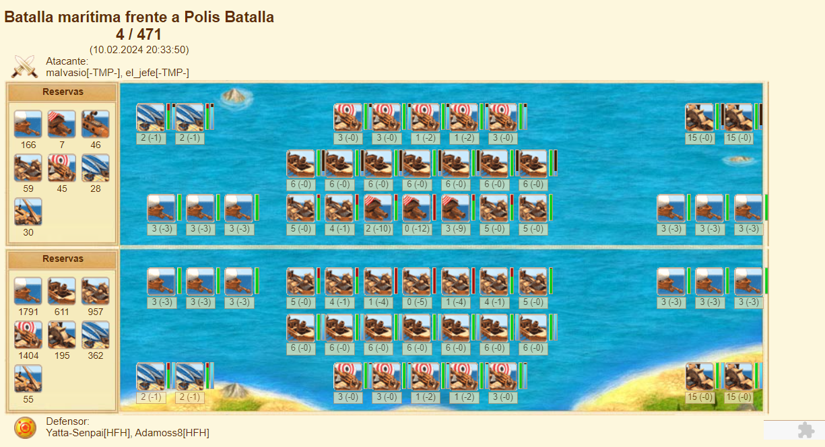

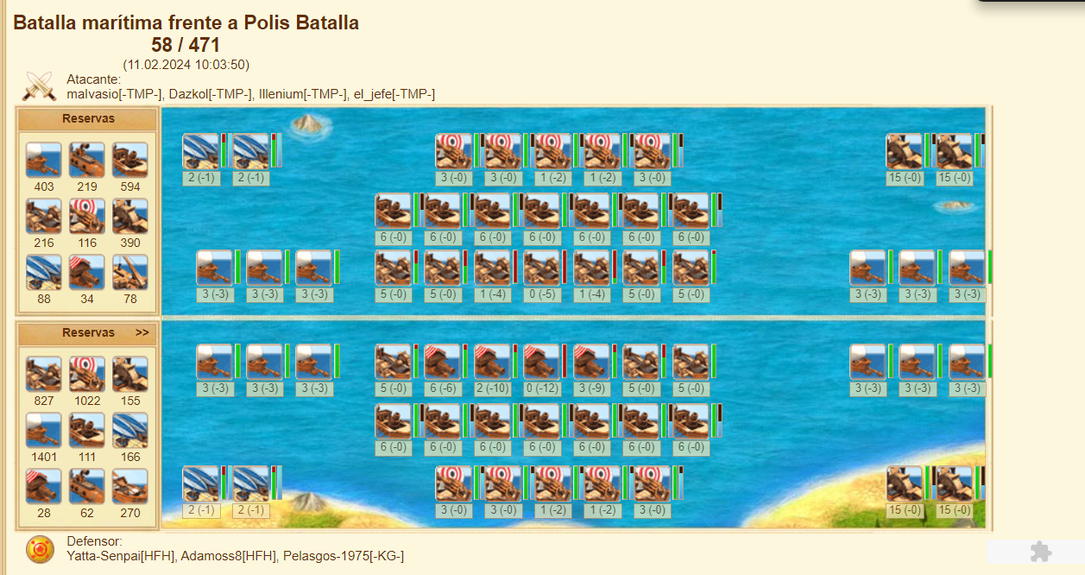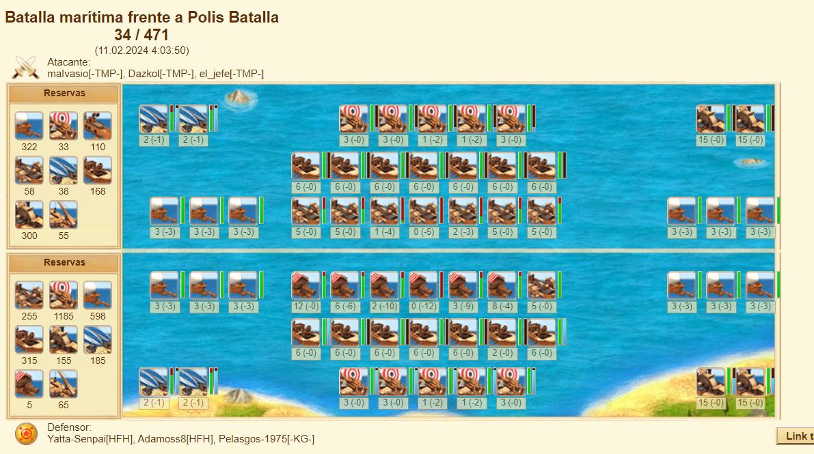Honorable mentions:

## Full Dives artillery lines

Full fires+rockets vs full steams+dives

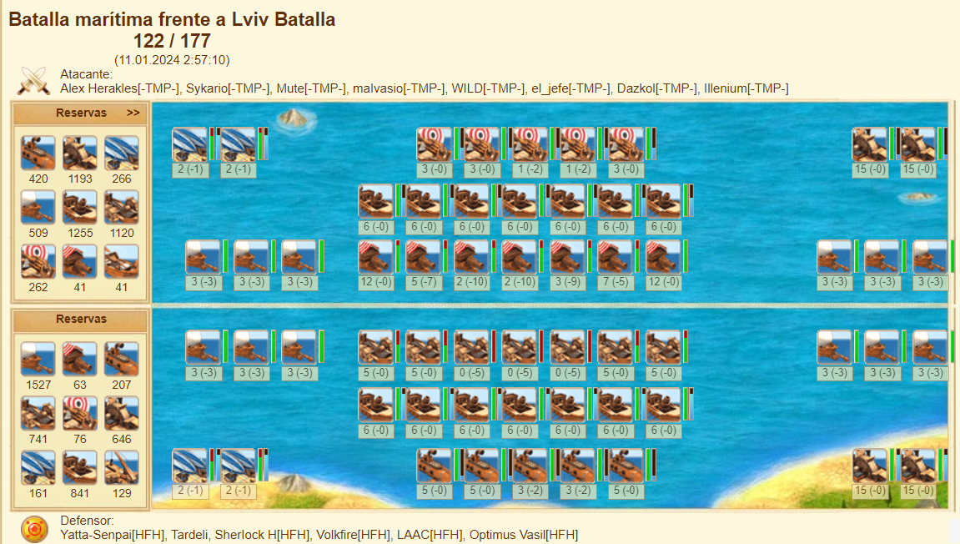

3waved fires+rockets vs 3waved fires + dives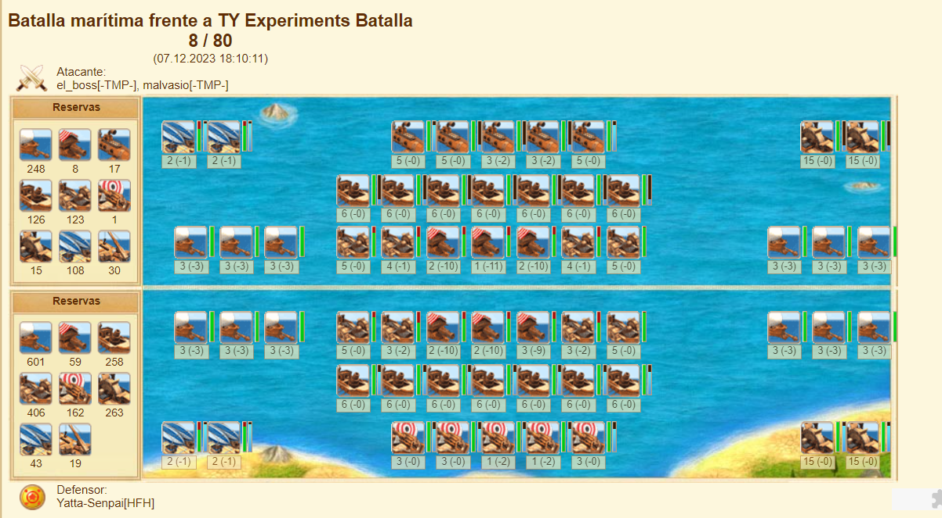

3w fires + dives vs steams + rockets

